I’m translating English to [ Vietnamese ]

(please write which language you’re translating!!)

Few words from Anne:

Thank you sooooo much for saying yes for the help!!!! I REALLY appreciate it!

The translations don’t need to be super strict and accurate,

(well if you can it def works better but don’t be stressed about it) all good as long as that makes sense to native speakers

AND if you don’t have the exact word or sentence/or hard to translate into one word/sentence, just leave it [blank]

Thanksss and ask me any questions if u guys havee!!

Let’s get this doneee >>>>>>>

NO NEED to be translated. Just for reference/context

Need to be translated! Actual sentences that being translate

**Screen #1 Language selection**

**Tone: Friendly :)**

*- Before we get started…*

*With which languages can you communicate?*

*What’s your language(s)?*

*- I can communicate with…..*

*(After selection)*

Sounds perfect!

OR

That’s awesome!

☺ ***Your translation here:***

Sounds perfect! = Tuyệt đấy!

That’s awesome! = Thật tuyệt vời!

**Screen #2 Pre-game**

**Tone: Friendly :)**

Hello and welcome to (game title)!

Let’s dive into the language ocean, shall we?

* I’d like to start with *word game.*
* I love challenges! Let’s go with *sentence game.*

☺ ***Your translation here:***

Hello and welcome to (game title)!= Chào mừng bạn đến với( )!

Let’s dive into the language ocean, shall we?= Chúng ta hãy đến với thế giới ngôn ngữ nhé?

* I’d like to start with *word game. =* Tôi muốn bắt đầu với trò chơi *từ ngữ.*
* I love challenges! Let’s go with *sentence game. =* Tôi yêu sự thử thách! Hãy bắt đầu với trò chơi *câu từ.*

**Screen #3 Word game**

**Tone: dictionary form**



Apple

☺ ***Your translation here:*** Apple= Táo



wave

☺ ***Your translation here:*** wave= sóng

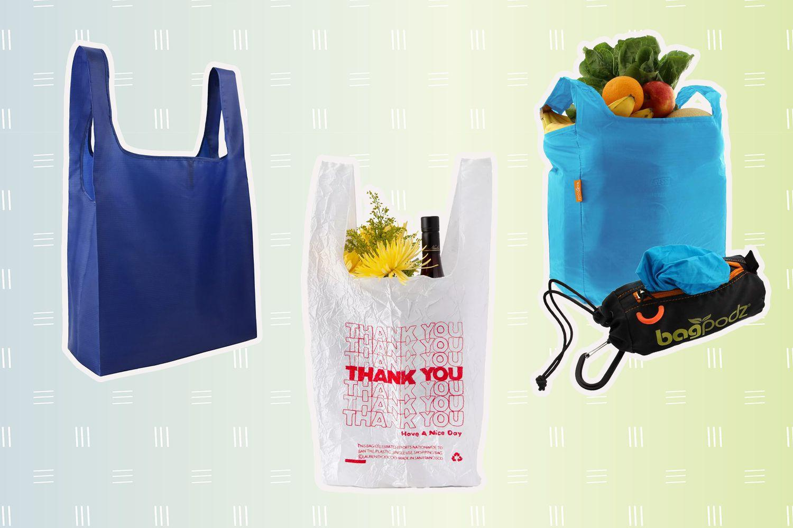

Shopping bag

☺ ***Your translation here:*** shopping bag= túi mua sắm



introduce

☺ ***Your translation here:*** introduce = giới thiệu

coffee

☺ ***Your translation here:*** coffee= cà phê



frozen

☺ ***Your translation here:*** Frozen= đóng băng



photography

☺ ***Your translation here:*** Photography= nhiếp ảnh



Reject

☺ ***Your translation here:*** reject= từ chối



Love

☺ ***Your translation here:*** love= yêu



Water

☺ ***Your translation here:*** Water= nước

**Screen #4 Sentence game**

**Tone: dictionary form**

Instruction:

So what I’m gonna do here is making a sentence game with each different language for each component.

For instance:

I / 사과 / 好きです

apple(in KR) like(in JP)

= I like apple.

So please write it into two forms if it’s possible:

Top one: as a sentence

Bottom one: dictionary form for each components

If your language has a different grammar, you don’t need to follow the separation and the order I gave, just classify them as they are :)

Also, those sentences contain some humors lol

I love to procrastinate.

I / love / to / procrastinate

☺ ***Your translation here(AS A SENTENCE):*** Tôi thích trì hoãn.

☺ ***Your translation here(SEPARATED COMPONENTS):*** Tôi / thích / / trì hoãn

I want a green apple.

I / want / a green apple

☺ ***Your translation here(AS A SENTENCE):*** Tôi muốn một quả táo xanh.

☺ ***Your translation here(SEPARATED COMPONENTS):*** Tôi / muốn / một quả táo xanh

Don’t make me run.

Don’t / make / me / run

☺ ***Your translation here(AS A SENTENCE):*** Đừng bắt tôi chạy.

☺ ***Your translation here(SEPARATED COMPONENTS):*** Đừng / bắt / tôi / chạy

I would like to have one cute cat, please.

I / would / like to / have / one cute cat /, please

☺ ***Your translation here(AS A SENTENCE):*** Làm ơi, tôi muốn có một con mèo dễ thương.

☺ ***Your translation here(SEPARATED COMPONENTS):*** tôi / would like to have = muốn có / một con mèo dễ thương / , làm ơn

I have zero in my bank account.

I / have / zero(nothing) / in / my / bank account

☺ ***Your translation here(AS A SENTENCE):*** Tôi không có tiền trong ngân hàng của tôi.

☺ ***Your translation here(SEPARATED COMPONENTS):*** Tôi / có / không / trong / của tôi / ngân hàng

At least I have my sandwich with me.

At least / I / have / my / sandwich / with me

☺ ***Your translation here(AS A SENTENCE):***  Ít nhất tôi có bánh mì kẹp của tôi với tôi.

☺ ***Your translation here(SEPARATED COMPONENTS):*** Ít nhất / tôi / có / của tôi / bánh mì kẹp / với tôi

I love lying in my bed all day.

I / love / lying in / my bed / all day.

☺ ***Your translation here(AS A SENTENCE):*** Tôi yêu thích nằm trên giường cả ngày.

☺ ***Your translation here(SEPARATED COMPONENTS):*** Tôi / yêu thích / nằm trên / giường / cả ngày.

I woke up at 5:00pm.

I / woke up / at / 5:00pm.

☺ ***Your translation here(AS A SENTENCE):*** Tôi dậy lúc 5 giờ chiều.

☺ ***Your translation here(SEPARATED COMPONENTS):*** Tôi / dậy / lúc / 5 giờ chiều.

***THATS ALL FOR TRANSLATION!! YEY***

***And JUST FOR FUN, if you’d like to share:***

Words/expressions/sentences that doesn’t exist in English?:

(For instance, ‘귀찮아(gwichana)’ in Korean means ‘that’s too much work so I would rather not do it’ but the dictionary says ‘its annoying,’ which is not a good refleciton 😂)